1. Implemented features / Completed Work and Design Decisions
In this sprint, our primary goal was Machine Learning Integration and System Finalization.
- Machine Learning Model: We efficiently cleaned our historical dataset, handled missing values, and performed feature selection to isolate relevant predictors (e.g., weather and time). We trained, compared, and evaluated multiple ML algorithms. Based on the evaluation, we made a design decision to export the best-performing model as a .pkl file, ensuring fast and efficient inference without the overhead of retraining on the fly.
- Full-Stack Integration: We built the React UI components and input forms for the prediction feature. We successfully implemented the fetch logic to submit user requests to our Flask backend API, which processes the data through the loaded .pkl model and returns a JSON response to dynamically render the results on the map.
- Quality Assurance: We designed and implemented comprehensive unit tests across the application. We successfully achieved an outstanding test coverage of 97%, ensuring a highly robust and reliable system for our final delivery.
- Design Decision on UI & Performance: We refined the visual style of our React components to ensure UI consistency across all pages. During testing, we observed a slight "cold start" latency on the first prediction click due to the model loading into memory. We made a design decision to accept this minimal initial delay, as it optimizes server memory usage, and all subsequent prediction requests are processed fast and seamlessly.

2. Burndown chart of sprint 4
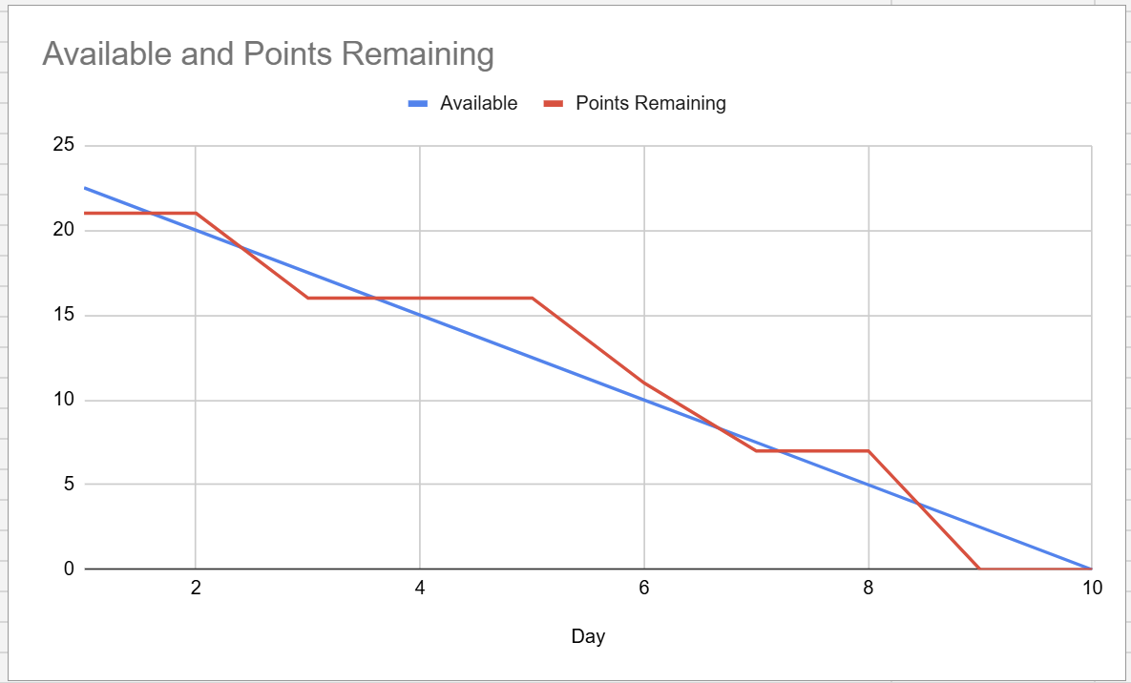
The Burndown chart illustrates a steady progression with a few plateaus, reflecting the complexity of our final integration tasks. Our "Points Remaining" line stayed slightly above the "Available" trend line during the middle of the sprint (Days 3-5) as the team was deeply involved in fine-tuning the machine learning algorithms and resolving frontend-backend API formatting issues. However, following a steep drop around Day 7, we regained our high velocity and successfully reached zero remaining tasks on Day 9, one day before the sprint deadline. This efficient completion allowed us to dedicate the final day strictly to code refactoring, ensuring UI consistency, and compiling our final project report.

3. Sprint Review
- Application Demonstration: Presented the fully functional web application, showcasing the seamless integration between the React frontend and Flask backend. We demonstrated the refined UI styling, highlighting how the consistent design provides a smooth user experience across all pages.
- Machine Learning Verification: Demonstrated the live predictive feature powered by our exported .pkl model. We showed how the frontend fetches data from the backend API and dynamically renders the prediction results. We also explained the slight "cold start" latency during the first click and proved the fast, seamless performance of all subsequent requests.
- Quality Assurance & Next Steps: Highlighted our achievement of 97% unit test coverage, proving the stability and reliability of our codebase. Since all core development is now complete, we discussed our strategy for the final 2-week phase, agreeing to focus strictly on code refactoring, UI/UX beautification, and compiling the final project report.

4. Sprint Retrospective
What went well:
Our team successfully completed the core Machine Learning pipeline and delivered the full web application. We efficiently cleaned our dataset, handled missing values, and isolated key predictors. After training multiple algorithms, we exported the best-performing model as a .pkl file and integrated it into our Flask backend. On the frontend, we smoothly implemented the React UI components and refined the visual style to ensure better UI consistency across all application pages. Furthermore, we achieved an outstanding unit test coverage of 97%, ensuring a highly robust and reliable system.

What could be improved:
Comparing algorithms and fine-tuning the model took more time than anticipated. Additionally, resolving minor API formatting issues during the frontend-backend integration required extra effort. During system testing, we observed a slight latency when a user clicks a station to view predictions for the first time. This initial delay occurs because the model takes a moment to load into memory, though all subsequent clicks are fast and seamless.

Final Conclusion:
As this is our final sprint, we have completed all core development tasks. We successfully overcame technical challenges to seamlessly integrate data scraping, the Flask backend, the React frontend, and ML predictions into a fully functional web application.

